ORDER OF EXECUTION SQL
Agenda :
- Introduction
- Logical Order of Execution
- SQL Query Execution Order
- Step-by-Step Execution of a Sample Query
- Final Output
- Difference Between Logical and Syntactical Order
- Logical Order
- Syntactical Order
Introduction
SQL Query Order of Execution is the arrangement in which a database framework executes SQL queries. It is imperative to understand the order of operations to optimize the execution order of sql queries and dodge errors.
Angelin recently accepted a new role as a Data Analyst for an expansive e-commerce company. She was energetic to learn and develop in her new role but rapidly found herself overpowered by the sum of information she had to work with. After some research and help from her team, Angelin decided to focus on mastering order of execution in SQL query. Angelin began by studying the basics of query execution order and the different methods of execution. Let's help her further.
Making an order is key when it comes to accomplishing a fruitful result. Usually true when preparing a cake, as you would like to preheat the stove, oil the skillet, and blend the fixings in the right order. The same guideline holds genuine when working with SQL queries, as the order of operations can majorly affect how productive and viable the query is.
Logical Order of Execution in SQL Queries
SQL queries are executed in a specific sequence, often referred to as the logical query processing order. Below is the logical order of execution for SQL queries:

Logical Order of Execution Steps
- FROM Clause
- WHERE Clause
- GROUP BY Clause
- HAVING Clause
- SELECT Clause
- ORDER BY Clause
- LIMIT/OFFSET Clause
Each step has a specific purpose and role in processing the query. Let’s break down each step in detail.
FROM
- The query begins by identifying the data source. This includes joining tables, applying aliases, and generating virtual tables.
- Example: Combining tables using JOIN or subqueries.
WHERE
- Filters rows based on specified conditions. Only rows meeting the condition will proceed to the next stage.
- Example: WHERE age > 30.
GROUP BY
- Groups rows based on specified columns, creating aggregated data sets for further processing.
- Example: GROUP BY department.
HAVING
- Filters groups created in the GROUP BY step based on a condition.
- Example: HAVING COUNT(*) > 5.
SELECT
- Selects specific columns or expressions to include in the final result set. This is where calculations, aliases, and derived columns are processed.
- Example: SELECT name, AVG(salary).
DISTINCT
- Removes duplicate rows from the result set.
- Example: SELECT DISTINCT city.
ORDER BY
- Sorts the rows in the result set based on specified columns or expressions.
- Example: ORDER BY salary DESC.
LIMIT/OFFSET (or FETCH FIRST)
- Restricts the number of rows returned in the final result set or skips a specific number of rows.
- Example: LIMIT 10 OFFSET 5.
Logical Order of Execution Summary Table
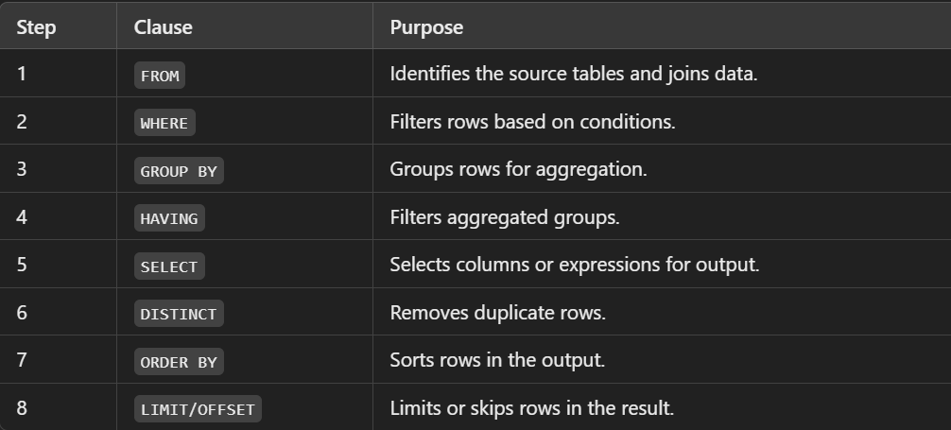
FROM Clause
- The FROM clause is the primary clause in a SQL statement and is utilized to indicate the source tables for the query. It characterizes the table or tables from which the information will be recovered and can incorporate optional join conditions that indicate how the tables ought to be associated.
Purpose:
- Identifies the tables or views from which data is retrieved.
- Forms the base dataset for the query.
- If multiple tables are involved, this is where joins (INNER, LEFT, RIGHT, FULL OUTER) are performed.
- For illustration, the following query recovers information from the "Customers" and "Orders" tables:
SELECT *
FROM Customers
INNER JOIN Orders
ON Customers.CustomerID = Orders.CustomerID;
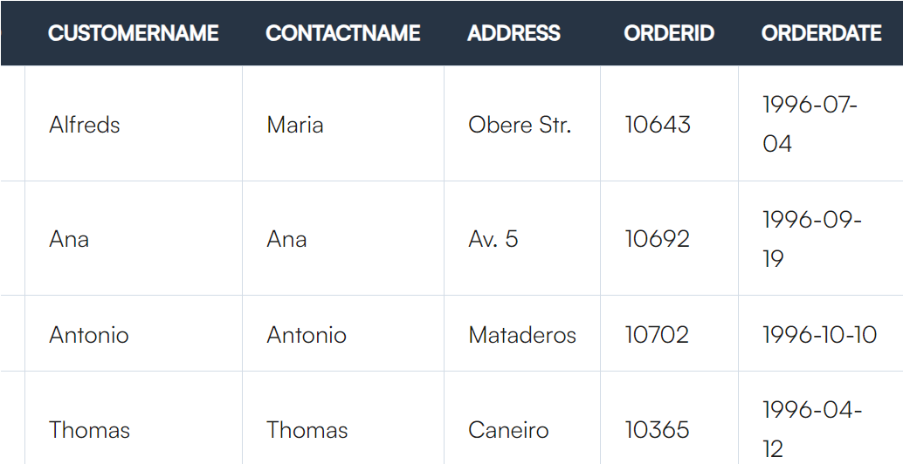
WHERE Clause
- The WHERE clause is the second clause in a SQL statement and is utilized to indicate criteria for filtering the data. It is utilized to limit the results of a query by applying a filter condition to the information recovered from the source tables.
Purpose:
- Filters rows based on a specified condition.
- Only rows that meet the condition proceed to the next step.
- For illustration, the following query recovers information from the "Customers" table, but only for customers with a CustomerID more prominent than 10:
SELECT *
FROM Customers
WHERE CustomerID > 10;
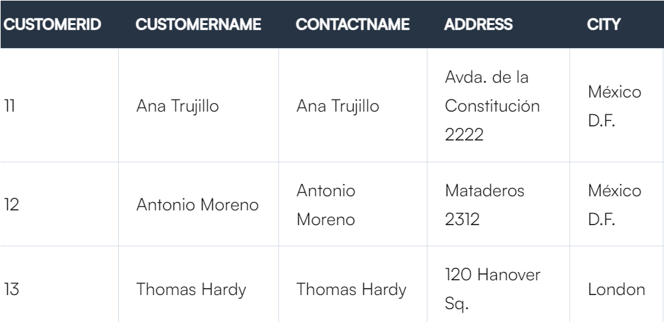
GROUP BY Clause
- The Group BY clause is the third clause in a SQL statement and is utilized to group information according to one or more columns. It is utilized to total the information retrieved from the source tables so that the information can be analyzed by grouping the information into categories.
Purpose:
- Groups rows that have the same values in specified columns.
- Used in conjunction with aggregate functions (e.g., COUNT, AVG, SUM).
- For illustration, the following query recovers information from the "Orders" table and groups it by the "CustomerID" column:
SELECT CustomerID, SUM(TotalPrice)
FROM Orders
GROUP BY CustomerID;
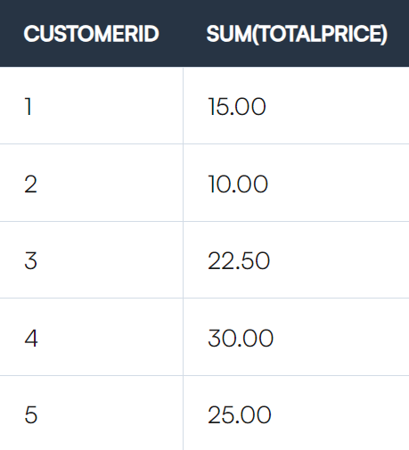
HAVING Clause
- The HAVING clause is the fourth clause in a SQL statement and is utilized to indicate conditions that must be met to return.
- It is utilized to channel the results of a query after the Group BY clause has grouped the information.
Purpose:
- Filters groups formed by the GROUP BY clause.
- Allows conditions on aggregated data.
- For illustration, the following query recoups information from the "Orders" table, groups it by the "CustomerID" column. It only returns results for customers with a add up to order sum greater than 1000:
SELECT CustomerID, SUM(TotalPrice)
FROM Orders
GROUP BY CustomerID
HAVING SUM(TotalPrice) > 1000;
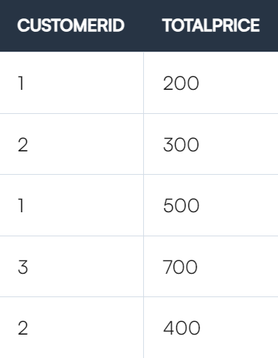
SELECT Clause
- The SELECT clause is the fifth clause in a SQL statement and is utilized to indicate the columns that will be returned within the query results. It is utilized to select which column from the source tables should be included in the query results.
Purpose:
- Specifies the columns to include in the result set.
- Performs column operations, including computed columns.
- For illustration, the following query recovers the "CustomerName" and "TotalPrice" columns from the "Clients" and "Orders" tables:
SELECT Customers.CustomerName, Orders.TotalPrice
FROM Customers
INNER JOIN Orders
ON Customers.CustomerID = Orders.CustomerID;
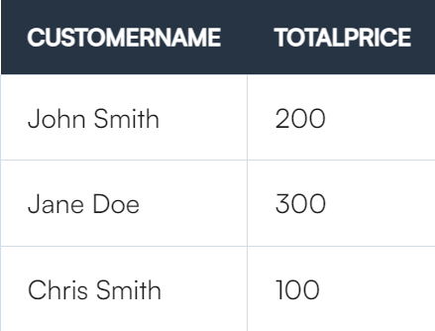
ORDER BY Clause
- The ORDER BY clause is the sixth clause in a SQL statement and is used to specify the order in which the query results should be returned. It is used to sort the data retrieved from the source tables in either ascending or descending order.
Purpose:
- Sorts the result set based on one or more columns, in ascending (ASC) or descending (DESC) order.
- For example, the following query retrieves data from the "Orders" table and orders the results by the "TotalPrice" column in descending order:
SELECT *
FROM Orders
ORDER BY TotalPrice DESC;
LIMIT Clause
- The Limit clause is the seventh clause in a SQL statement and is utilized to limit the number of records that will be returned within the query results. It is utilized to restrict the number of rows returned from the source tables, permitting you to indicate a particular number or a range of records to be returned.
Purpose:
- Restricts the number of rows returned by the query.
- Useful for pagination.
- For illustration, the following query recovers the first 10 records from the "Orders" table:
SELECT *
FROM Orders
LIMIT 10;
SQL Query Execution Order
An SQL query's execution is performed in a logical sequence that differs from the order in which it is written. Below is the logical order of execution for an SQL query:
- FROM: Identify the data source.
- ON: Filter rows based on join conditions.
- JOIN: Combine data from multiple tables.
- WHERE: Filter rows before grouping.
- GROUP BY: Organize rows into groups.
- HAVING: Filter groups based on aggregate functions.
- SELECT: Retrieve columns and apply computations.
- DISTINCT: Remove duplicate rows.
- ORDER BY: Sort the rows.
- LIMIT/OFFSET: Limit the number of rows returned.
Written vs Logical Order of SQL Query
SELECT DISTINCT column1, aggregate_function(column2)
FROM table1
JOIN table2 ON table1.id = table2.id
WHERE condition
GROUP BY column1
HAVING condition
ORDER BY column1
LIMIT n;
Logical execution starts with FROM and proceeds to LIMIT.
Step-by-Step Execution of a Sample Query
Let’s take a sample query and break it down step-by-step:
Sample Query:
SELECT department_id, AVG(salary) AS avg_salary
FROM employees
WHERE job_title = 'Developer'
GROUP BY department_id
HAVING AVG(salary) > 70000
ORDER BY avg_salary DESC;
Execution Steps:
- FROM employees
  - Identify the employees table as the data source.
  - Intermediate result: The entire employees table.
- WHERE job_title = 'Developer'
  - Filter rows where the job_title is ‘Developer’.
  - Intermediate result: A subset of rows with job_title = 'Developer'.
- GROUP BY department_id
  - Group rows based on department_id.
  - Intermediate result: Groups of employees belonging to each department.
- SELECT department_id, AVG(salary) AS avg_salary
  - Compute the average salary for each department and select the department_id and calculated average.
  - Intermediate result: A table with department_id and avg_salary.
- HAVING AVG(salary) > 70000
  - Filter groups where the average salary is greater than 70,000.
  - Intermediate result: Departments with average salaries exceeding 70,000.
- ORDER BY avg_salary DESC
  - Sort the results by avg_salary in descending order.
  - Final result: Ordered departments with high average salaries.
Final Output:
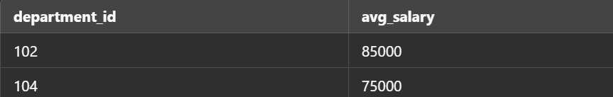
Difference Between Logical and Syntactical Order
Logical Order
Logical order refers to the sequence of steps or instructions that align with the problem-solving process. It represents the logical flow of a program or algorithm to achieve the desired outcome. Logical order ensures the program follows the appropriate reasoning or decision-making to solve a problem.
Key Characteristics of Logical Order:
- Problem-Oriented: Logical order is based on the flow required to solve the given problem.
- Algorithmic Design: It involves steps in algorithms or pseudocode.
- Independent of Programming Language: Logical order is not tied to any specific syntax.
- Focuses on "What" and "Why": It prioritizes what needs to be done and why each step is necessary.
- Abstract: Logical order exists at a higher abstraction level than actual coding.
Syntactical Order
Syntactical order refers to the sequence of statements in code that conforms to the rules and syntax of a programming language. It ensures the code is valid and executable by the compiler or interpreter.
Key Characteristics of Syntactical Order:
- Language-Specific: Syntactical order depends on the programming language used (e.g., Python, C++, Java).
- Grammar-Oriented: It follows the grammar and structure (syntax) of the language.
- Focuses on "How": It emphasizes how the logic is implemented in the chosen programming language.
- Enforced by the Compiler/Interpreter: Errors in syntactical order lead to syntax errors.
- Concrete: Syntactical order is concrete and visible in the code.
Comparison Between Logical and Syntactical Order
